Exp1:-
Title of the program:-
Write a program to convert the temperature reading in Farenheit scale to Celsius & Kelvin scale. Write the flowchart of the program.
Flowchart:-

Start

float f,c,k
c=(5*(f-32))/9
Print c
End
k=c+273
Print k

Program instruction:-
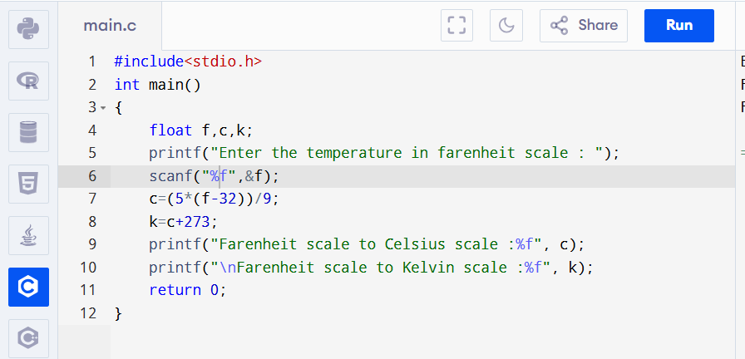
Output:-
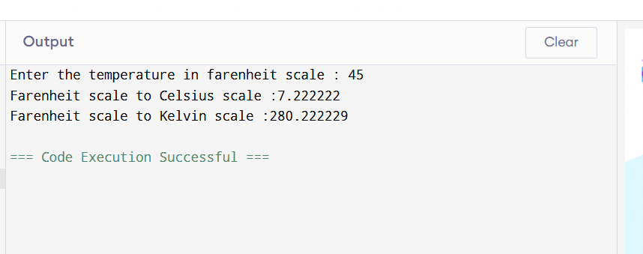

Exp2:-
Title of the program:-
A student has secured marks in 5 subject (out of 100) write a program to compute the aggregate and if the marks is greater than or equal to 80% then print “Excellent” else print “Average”. Write the flowchart of the program.
Flowchart:-
Start

int n,i=0,sum=0,ave
Take the value of n
sum=sum+n
i=i+1
if i<5
ave=sum/5
if
ave<=80
print Excellent
print Average
End
Yes
No
No
Yes

Program instruction:-
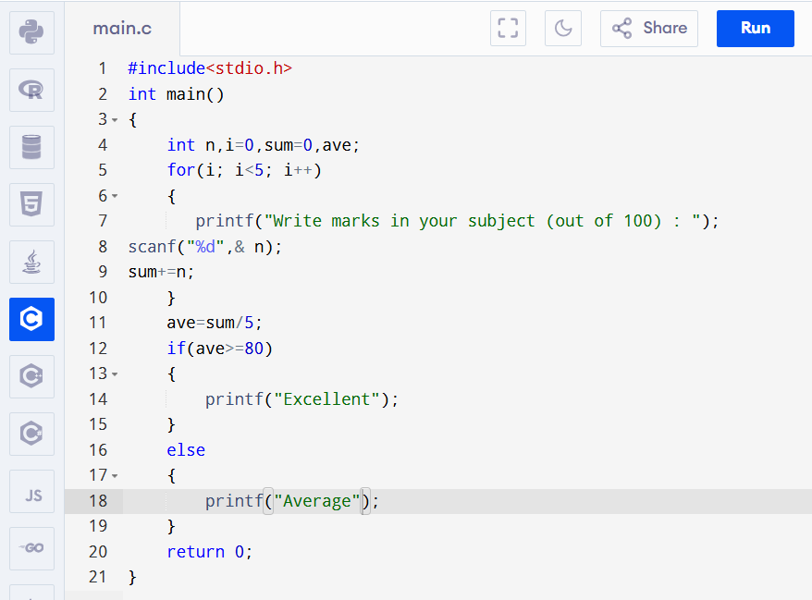
Output:-
